Buiksloterham can serve as an example for the future of Dutch planning
Reflections on the incorporation of participation in Dutch planning processes
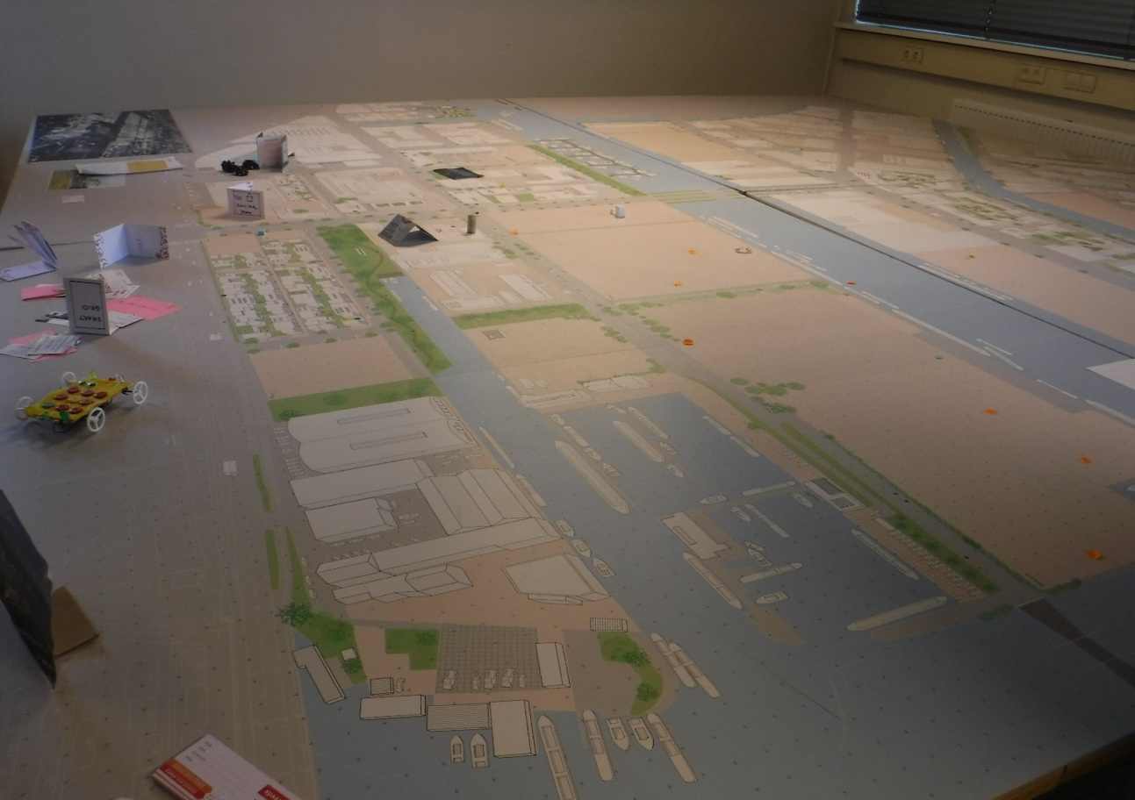
Wageningen University & Reserach
Reflections on Planning and Desing Practices
LAR-37306
Sven van den Bos 960219105040
Laurens Carpentier 941006155050
Marieke de Haas 960207295060
Giovanni Pagano 920128640080
I have read and agree the WUR plagiarism guidelines.

Abstract
This essay reflects on the participation in the transformation of Buiksloterham, from an unwanted and polluted area towards a much desired living area. The goal is to explore to what extent Buiksloterham can serve as an example for the future of Dutch planning and can provide lessons for the implementation of the Omgevingswet. It does so by putting Buiksloterham in a historical context by exploring the important actors who take part in this transformation. The participation process is reflected upon through different theoretical lenses: conformance, performance and narratives, which have been addressed in the interview with Stadslab Circulair Buiksloterham, a local entrepreneurial company. Lastly, the case of the Old Docks in Ghent, Belgium has been analyzed to explore similarities and differences. All in all, if Buiksloterham wants to become an example for the Omgevingswet, more recognition should be given to important local stakeholders to create a more balanced planning context.
KEYWORDS: Participation, Conformance, Performance, Narratives, Dutch planning, Omgevinswet

Table of contents
1. Introduction 3
2. Actors 4
2.1. Entrepreneurs 4
2.2. Government 4
2.3. NGO’s 5
3. Theoretical framework 5
3.1. Participation 5
3.2. Conformance and Performance 6
3.3. Narratives 6
4. Participation, performance and narratives in Buiksloterham 7
4.1. Participation in Buiksloterham 7
4.2. Performance in Buiksloterham 8
4.3. Narratives in Buiksloterham 9
5. A similar situation in Belgium: The Old Docks of Ghent 9
6. Conclusion 11
7. References 12

1. Introduction
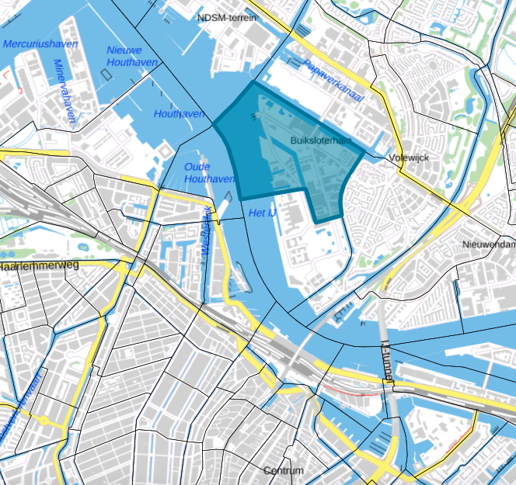
Throughout history, the Buiksloterham has never been a popular spot in Amsterdam. The sludge in the river IJ where waste from the city was disposed, settled and eventually gave the area a solid land structure (Interview Stadslab Circulair Buiksloterham). In the 19th century the Buiksloterham developed as an industrial shipping wharf, that caused an enormous amount of pollution whose traces are still to be found in the soil (Dembski, 2013). However, from the late 20th century onwards, the city council and land developers started to show interest in the area as there was a housing shortage (Gladek, Van Odijk, Theuws & Herder, 2014). The connection with the city centre improved ever since ferries cross the river 24/7 (Dembski, 2013). The crisis in 2008 halted most development which even resulted in plots being given away (Interview Stadslab Circulair Buiksloterham). However, today, the Buiksloterham has become a very popular living/working area in Amsterdam. In this context, the ambitious plans on sustainability, ecology and living quality form an important asset (Interview Stadslab Circulair Buiksloterham).
Figure 1. Source: https://www.pdok.nl/viewer/#
In this essay we focus on how planning participation is part of the developments in the Buiksloterham. In doing so, first actors in Buiksloterham are outlined. Consequently, different theoretical planning models are applied to analyse how participation was implemented in practice. Additionally, the current status of the Omgevingswet (Environmental Planning Act) is evaluated and how it relates to participation in the Buiksloterham. Participation in the decision making on planning is an essential part of the Omgevingswet. However, a clear approach on how it should take shape in practice is until now still not clearly articulated with official guidelines. In the context of changed planning law, the essay hopes to be an added value as it draws on theory and real life experiences of participation in the Buiksloterham. Accordingly, it will hopefully be able to provide more insights around the existing uncertainties concerning the Omgevingswet and the successful completion of the ambitious plans that are made for a Circular Buiksloterham. Ultimately, there is a reflection on how applied models of planning participation would function in another, international.
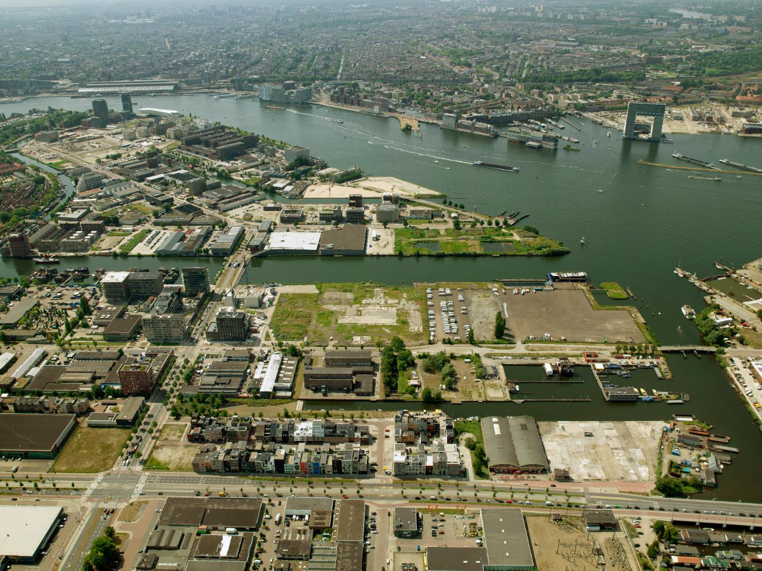
Figure 2. Source: https://buiksloterham.nl/bericht/39355/inspraak-investeringsnota-buiksloterham-2019-vertraagd

2. Actors
In 2014 a manifest was created as a guideline for the development of Buiksloterham (Gladek et al., 2014). This manifest was signed by various actors and parties. The most prominent ones will be discussed below to provide an image of the actors and the sphere of influence in which the development of Buiksloterham takes place.

2.1. Entrepreneurs
There are multiple entrepreneurs in the area of Buiksloterham. Many of the people living there have designed and built their own house and are thus true pioneers in Buiksloterham (Gemeente Amsterdam, n.d.; Interview Stadslab Circulair Buiksloterham). Additionally, there are different entrepreneurs, such as Metabolic and Studio Valkenier, who have worked on the development of De Ceuvel. De Ceuvel is a prominent actor in the Buiksloterham as the vision of its entrepreneurs was not only to create and experiment with circularity in Amsterdam, but to spread this knowledge all over the world and so putting Amsterdam on the map. To de Ceuvel, spreading this knowledge is essential in the transition from linear to circular development. ‘This transition is just as much a cultural as a technical shift’ (De Ceuvel, n.d.). Additionally, in making the area circular and sustainable, infrastructural companies that are to implement water, gas, waste and electricity facilities are very important actors to consider as well.

2.2. Government
The most important actor in the area is considered the municipality of Amsterdam since they own about one third of the land. They have a clear vision on the future of Buiksloterham, as can be derived from this statement: “Buiksloterham will change to a sustainable area. Where living and working naturally complement each other, with space for creative, adventurous entrepreneurs and inhabitants.”
The above quote represents the inspirational vision on the Buiksloterham area as presented by Els Daems, Projectmanager Buiksloterham from the municipality of Amsterdam (Gemeente Amsterdam, n.d). It triggers the imagination: an innovative, experimental and participative way of urban development of Northern Amsterdam. The innovative and participative nature of development of Buiksloterham seems to fit within the soon-to-be-implemented Omgevingswet (Environmental Planning Act). This national planning act serves to simplify and combine existing regulations on spatial planning. Accordingly, it should become easier to initiate city development. The Omgevingswet should be implemented by 2021 (Rijksoverheid.nl, n.d.). Similar to the context of development in the Buiksloterham, participation is an important pillar in the Omgevingswet. Its relevance is framed as follow: “Initial collaboration enhances the quality of solutions and will see to it that different perspectives, knowledge and creativity will be part of the process.” Following this approach, a circular and sustainable Buiksloterham should be realizable (Aan de slag met de Omgevingswet, 2019).

2.3. NGO’s
Other actors within Buiksloterham are numerous non-profit organisations, such as Stadslab Circulair Buiksloterham and Stories Verhalenkantine Buiksloterham, which aim to increase the awareness and processes on sustainability and circularity within this area through bottom-up approaches (Buiksloterham, n.d.). They aim to cooperate with both local entrepreneurs and the government to increase cohesion, stimulate participatory and sustainable development. Accordingly, they were the initiators of the manifesto.

3. Theoretical framework
In this section theories that can help identify whether or not Buiksloterham can serve as an example for the future of Dutch planning are discussed.

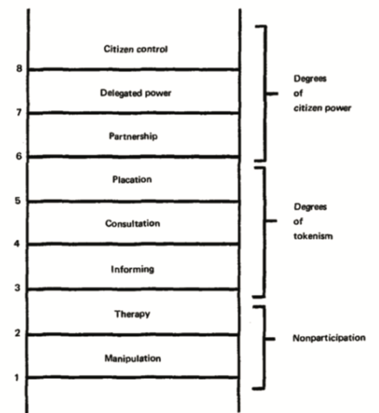
3.1. Participation
Figure 3. Source: (Arnstein, 1969, p.217)
At the base of participation, according to Arnstein (1969), there is the redistribution of power in which, to the so-called have-nots in our society are given more control over their lives. Participation can include education and information, review and reaction, interaction and dialogue (Pettersson, Stjernström, & Keskitalo, 2017).
The way of thinking about participation developed overtime: the first wave was in the 60s with Arnstein (1969), to include more democracy in decision-making processes; in the 80s it was a way to get the support from the citizen; in the 90s the goal of participation was to improve the quality of the plan. Instead, nowadays, it is a way to educate the citizens about different matters. Consequently, its concept brings new challenges as to how to identify the parties who should be included and excluded. For instance, should participation concern citizens, local governments, science or other parties? (Pettersson et al., 2017).
Accordingly, Healey (1997), provoked the society with his book on, how it is defined, “collaborative planning”. He refers to it “as a strategic approach to the ‘governance of place’” (Healey, 2003, p.116). The goal is to gather stakeholders and engage them in a process to make decisions together in a way that respects the position of everyone involved to improve the plan quality. In this way, it is Healy’s intention to have the knowledge of local people to have an influence in the output of the plan.

3.2. Conformance and Performance
Finally, participation can also be evaluated based on its effectiveness. Effectiveness represents the degree of closeness of the achieved results within the predetermined goals. In other words, whether the results are in accordance to specified objectives (Needham et al., 2018). Accordingly, two system models on the effectiveness of planning cohabit in Europe: a more traditional one striving single projects to a collective strategy, so called “conformance”; and a less institutionalized one, promoting those projects capable of performing a collective strategy, so called “performance” (Janin Rivolin, 2008). The former, refers to an action in accordance with some specified standard protocol or authority (Janin Rivolin, 2008), whereas the latter, means that planning objectives can also be reached without sticking to the original plan (Mastop & Faludi, 1997).

3.3. Narratives
Narratives are an important aspect of the planning process. A narrative can be seen as a discourse, or story, formed by order, space and time. In other words, it is ‘’the activity of selecting, arranging and rendering story material in order to achieve specific time-bounds effect on a perceiver’’ (Psarra, 2009, p.2). A narrative is a social and political construct which creates connections between objects and practices. This creates discourses with which people can identify (Howarth, Norval, & Stavrakakis, 2000).
The power of narratives in planning lays in the fact that stories can be used to change public opinions (Van der Stoep, 2014). In doing so, stories have to be created by including different perspectives of planners and other geohistorical actors. A common urban narrative has to be created from diverse opinions. This will enable planners and other actors to engage in a profitable dialogue with the public (Throgmorton, 2003), since narratives have the power to improve inclusiveness of actors and make issues more negotiable (Baker, 2010).
However, such a narrative is not easily created. The targeted audience will not always conceive the intended message sent by planners, elected officials or other actors. Besides that, there is never just one story to be told. Stories are always contesting with other stories and can possibly undermine one another. Moreover, stories are very much bound to context. Therefore, stories can have multiple, contesting meanings (Throgmorton, 2003). Nonetheless, if a story is told well, planners have the ability to steer its receivers’ senses towards what is possible and more importantly, desirable. Narratives can empower readers to envision desirable transformations in their cities, form a source of inspiration, construct a ground for action and create a belief that their actions matter (Throgmorton, 2003).

4. Participation, performance and narratives in Buiksloterham

4.1. Participation in Buiksloterham
Clearly, Stadslab plays a pivotal role in the participation process due to its closeness with the inhabitants and entreprises in the area. The experimental objective of the municipality on Buiksloterham led to the open planning process where Stadslab is working in. Accordingly, it has been stated that “whoever wants to join is welcome” (Interview Stadslab Circulair Buiksloterham).
At the beginning of the development process, in 2012, during the economic crisis, the municipality decided to sell individual plots to private developers in accordance to sustainability criteria (Interview Stadslab Circulair Buiksloterham). This, according to Arnstein (1969), could be identified as a form of “delegate power”, because the municipality of Amsterdam shifted away from an active land policy empowering citizen to develop their own plans. Thus, citizens have obtained “the majority of decision-making seats” (Arnstein, 1969, p.217).
Consequently, only after the declaration on a circular area, Stadslab started to be actively involved in the development process. At the beginning only few inhabitants, around 40, were living in the area, so Stadslab shifted from institutional plans to pay more attention to the ‘people needs’ (Interview Stadslab Circulair Buiksloterham). This can be identified as a way to gain support from the citizens and improve the quality of the plan. Additionally, in internet a platform became available (buiksloterham.nl) where everyone is welcome to upload ideas, articles, messages or any types of comments reagarding Buiksloterham’s developments. This initiative is a way to educate inhabitants about different issue, and it gives them agency to be more informed about issues related to the neighbourhood. It allows citizens to hear and to be heard.
Stadslab also tried to organize meetings where at the order of the day there would have been a pool for future plans or implementation (Interview Stadslab Circulair Buiksloterham). However, this idea would have cost Stadslab more than anticipated and therefore decided to revise their plans. However, this kind of initiative could have been classified, according to Arnstein (1969), as “citizen control” because it would have given to the inhabitants “full managerial power” (Arnstein, 1969, p.217).
The area has proven attractive for architects, urban planners and experts in sustainability to live. Stadslab has actively been trying to bring all these experts living in the area together in evening meetings or focus group, in order to share their knowledge and ideas for a broader audience (Interview Stadslab Circulair Buiksloterham). This can be identified as collaborative planning, where a niche of people, experts in this case, are bringing together their knowledge and new ideas to increase the quality of the plan (Healey, 2003).
In conclusion, participation in the Buiksloterham planning is ubiquitous; different ideas from different groups have been taken into account. In several ways, Stadslab has initiated democratic processes to improve the quality of the plan and educate citizens. However, participation makes implementation of the plans more complex. Practice has taught that the more actors are involved, the more time is required for the implementation of the plans (Interview Stadslab Circulair Buiksloterham). =

4.2. Performance in Buiksloterham
The manifesto, which was signed by many parties, did not include any clear path on how to reach the objectives in the original plans. In this way it becomes clear that the municipality of Amsterdam seems to have adopted a performance-informed planning model for Buiksloterham with circularity, sustainability and innovation being the main objectives. In this way it can be argued that innovation goes hand in hand with performance, as “performance is defined as the capacity in shaping the minds of actors in spatial development [...]” (Janin Rivolin, 2008, p.170).
Hence, the performance-based approach in Buiksloterham is well aligned with the goals of the Omgevingswet. Not only does the Omgevingswet serve to streamline existing regulations on spatial planning, it also encourages to integrate as much participation in spatial planning projects as possible. Its goal is to include all sectors of spatial planning and ensure that civilians have the opportunity to realize their initiatives (Aan de slag met de Omgevingswet, 2019). Since Stadslab tries to initiate a dialogue between as many sectors as possible and since Buiksloterham.nl seems to give all civilians a platform to raise their ideas and voice their concerns, the development of Buiksloterham seems to be exemplary for the envisioned future implementation of the Omgevingswet.

4.3. Narratives in Buiksloterham
When following the narrative revolving the Buiksloterham as set out by the municipality, it is clear it incorporates great ambitions in terms of sustainability and circularity. It has the potential to increase inclusiveness and make participation issues more negotiable while creating a coherent vision of what the area might look like. Aiding this narrative is the manifesto that was created and signed by many parties such as the municipality, Metabolic and Waternet (Gladek et al., 2014). The fact that so many actors share the same vision is beneficial and promising for the developments, as it prevents potential competition as described by Throgmorton (2003), between actors that would undermine the narrative of Buiksloterham as a sustainable area. Additionally, Stadslab Circulair Buiksloterham has very close ties to the local residents and entrepreneurs. This will be very helpful towards carrying out the shared message of the manifest, which strengthens the narrative, creates momentum and overall improves the participation in the development process of Buiksloterham (Interview Stadslab Circulair Buiksloterham).

5. A similar situation in Belgium: The Old Docks of Ghent
The Old docks of Ghent form a former industrial site that functioned as the harbour of the city. Today it is being transformed into a mixed-use living and working area. The concept of the old docks has a strong resemblance to the Buiksloterham because of its former function, its central location and the importance of participation in its planning process.
In 2004 the municipality selected the urban design studio Office for Metropolitan Architecture (OMA) for the development of the old docks. OMA came up with a design plan that described the area in layers of industry, leisure and living in a so-called “brochette” model (SOGent, 2017; HUB, 2013). In 2006 the municipality translated the design plans to legal urban legislation plans. This caused protest from the surrounding inhabitants (Interview SOGENT, 2019). To the inhabitants the plan was not received well as it lacked green spaces. Additionally, there were objections that the focus of development was too strong on private owners (Interview SOGENT, 2019).
After local elections in 2016, the development process of the Old Docks changed by offering a platform to the local community living around this area (Interview SOGENT, 2019). SOGent, a private organisation, was addressed in 2003 by the city as the initiator of the development. Interestingly, the municipality is their only stockholder. They owned 90% of the ground and had the most power as actor in this development (SOGent, 2017). SoGent organised working groups, events and dialogue cafe’s to translate the voice of the citizens to the planning process (SOGent, 2017). With the participation of these local organisations, a part of the development was secured for a public park. Moreover, the government set some targets as to develop 20% of the buildings as social housing and 20% affordable housing with room for workspaces, shops and greenspaces (van Den Ende, 2017).
Figure 4. https://ec.europa.eu/regional_policy/en/projects/belgium/construction-of-a-new-district-in-ghent-brings-new-life-to-old-docks

In conclusion, it is evident that despite the many similarities between both the Buiksloterham and the Old Docks they are developed in countries, respectively with a different vision on urban planning and political systems. In Buiksloterham the municipality, who is the main developer, allowed room for experimentation and participation with input from private sector, government and local communities. As argued above, its approach can be classified rather performance-informed, as the objectives are not set in terms of process. The old docks on the contrary started off with a conformance-based approach grounded in set protocols and envisioned goals. This resulted in a conflict with the local community, who felt that their voice did not mattered towards the final realization of the project. It is believed that if the same kind of participation processes would have been implemented in the Old Docks compared to Buiksloterham, there would have been already much more of working/living goals achieved.

6. Conclusion
Buiksloterham is an exciting neighbourhood in North Amsterdam and becoming renowned for the experiments and innovation in the planning process and sustainable design. The participation process was reflected upon through different theoretical lenses: conformance, performance and narratives, which have been addressed in the interview with Stadslab Circulair Buiksloterham, a local entrepreneurial company. Accordingly and beyond these premises, this essay looked at how it can serve as an example for Dutch planning.
The exact approach on how implementation should lead to the desirable execution of plans is not specified, neither in the Omgevingswet nor by the municipality. In this way, it can be stated that the municipality of Amsterdam seems to have adopted a performance-informed planning model count on the local entrepreneurs, private actors and civilians to achieve the established objectives. Moreover, when following the narrative, it has an important role to increase the inclusiveness of- and involvement of different in the participation process. Thus, on the one hand, different perspective from different actors have been taken into account in the development of Buiksloterham. Stadslab, above all, has ventured a more democratic process with the objective to improve the quality of the plans and to educate citizens about sustainability practices. On the other hand, the more are the actors involved, the more complicated the planning process gets, requiring more coordination between actors.
All in all, in considering both Buiksloterham and the Old Docks in Ghent, a very important lesson was learned, namely that translating circularity back to actual development requires more than stories alone. The connecting actors like Stadslab that are so vital for this coordination, seem not to have been taken seriously enough by the municipality, at least in the beginning. They do not seem to receive enough funding for the assets that they add through connecting all actors in the planning process in realizing circularity. Instead, they had to prove their worth by investing a lot of time and own resources before being able to considerably contribute to the planning process. Therefore we think the planning process could definitely be improved by giving more recognition to connecting actors like Stadslab to create a planning context in which the planning processes as currently going on in Buiksloterham will become state-of the art once the Omgevingswet will be implemented.

7. References
Aan de slag met de Omgevingswet (2019). Anders werken. 11-9-2019, from: https://aandeslagmetdeomgevingswet.nl/omgevingswet/anders-werken/

Amsterdam Smart City (2016). De Ceuvel. Retrieved 30 september 2019, from: https://amsterdamsmartcity.com/projects/the-ceuvel
Arnstein, S. R. (1969). A Ladder Of Citizen Participation. Journal of the American Institute of Planners, 35(4), 216-224. doi:10.1080/01944366908977225
Buiksloterham (n.d.). Organisaties. Retrieved 30 september 2019, from https://buiksloterham.nl/engine?service=velocity:/web/lijst/organisaties.vm
De Ceuvel (n.d.). Wat is de Ceuvel? Retrieved 20-9-2019, from https://deceuvel.nl/nl/about/general-information/
De Haas, M.B.J., (Photographer). (24-10-2019). Development in Buiksloterham on the table [photograph]. Amsterdam, unpublished: De Haas Ventures.
Dembski, S (2013). Case Study Amsterdam Buiksloterham, the Netherlands: The Challenge of Planning Organic Transformation. CONTEXT Report 2. AISSR programme group Urban Planning, Amsterdam.
Gemeente Amsterdam (n.d.). Een soort hooischuur op palen. Retrieved 30-9-2019, from https://www.amsterdam.nl/wonen-leefomgeving/zelfbouw/verhalen/soort-hooischuur/
Gladek, E., Van Odijk, S., Theuws, P., Herder, A (2014). Circular Buiksloterham. Transitioning Amsterdam to a Circular City. Retrieved 11-9-2019 from https://buiksloterham.nl/engine/download/blob/gebiedsplatform/69870/2015/28/CircularBuiksloterham_ENG_Executive_Summary_05_03_2015.pdf?app=gebiedsplatform&class=9096&id=64&field=69870
Healey, P., (2003). Collaborative planning in perspective. Planning Theory, 2(2), 101-123.
Howarth, D. J., Howarth, D. R., Norval, A. J., & Stavrakakis, Y. (Eds.). (2000). Discourse theory and political analysis: Identities, hegemonies and social change. Manchester University Press.
HUB, (2013). Requalification of the Old Docks, Ghent. Retrieved 11-10-2019 from http://www.hub.eu/projects/Requalification-of-the-old-docks-Ghent#8
Kirkenier, J. M. V. (2016). ‘Help mijn buurt wordt hip’ Een onderzoek naar burgerparticipatie en support organisaties in duurzame stadstransformatie in Buiksloterham, Amsterdam (Bachelor's thesis).
Lata, I. B., & Duineveld, M. (2019). A harbour on land: De Ceuvel’s topologies of creative reuse. Environment and Planning A. https://doi.org/10.1177/0308518X19860540
Janin Rivolin, U., (2008), Conforming and Performing Planning Systems in Europe: An Unbearable Cohabitation, Planning Practice and Research, 23(2),167-186.
Mastop, H., & Faludi, A. (1997). Evaluation of strategic plans: the performance principle. Environment and Planning B: Planning and Design, 24(6), 815-832.
Needham, B., Buitelaar, E., & Hartmann, T. (2018). Planning, Law and Economics: The Rules We Make for Using Land (2nd edition).
Pettersson, M., Stjernström, O., & Keskitalo, E. C. H. (2017). The role of participation in the planning process: examples from Sweden. Local Environment, 22(8), 986-997. doi:10.1080/13549839.2017.1319805
Psarra, S. (2009). Architecture and Narrative: The formation of space and cultural meaning. Routledge, Abingdon.

Rijksoverheid, (n.d). Omgevinswet. Retrieved 30-9-2019 via: https://www.rijksoverheid.nl/onderwerpen/omgevingswet
Savini, F., Boterman, W. R., Van Gent, W. P., & Majoor, S. (2016). Amsterdam in the 21st century: Geography, housing, spatial development and politics. Cities, 52, 103-113.
SOGent. (2017). Oude Dokken. Retrieved 11-9-2019 from https://sogent.be/projecten/oude-dokken
SOGent.( 2018). 15 Jaar stadsontwikkeling in de Oude Dokken. Retrieved 11 October, 2019 from https://sogent.be/15-jaar-stadsontwikkeling-de-oude-dokken

Throgmorton, J. A. (2003). Planning as persuasive storytelling in a global-scale web of relationships. Planning Theory, 2(2), 125-151.

Van den Ende, T.(2017). Leren van de Gentse aanpak: hoe steun je tijdelijk initiatief?. Retrieved 11-9-2019 from: https://www.gebiedsontwikkeling.nu/artikelen/leren-van-de-gentse-aanpak-hoe-steun-je-tijdelijk-initiatief/

Van den Bussche, S.(2018). Speculatie verdrijft inwoners aan Oude Dokken. Retrieved 11-9-2019 from: https://www.apache.be/2018/09/03/speculatie-verdrijft-inwoners-aan-oude-dokken/?sh=b2c88ed3180cdaaa905b7-40021154

van der Stoep, H. (2014). Stories becoming sticky: How civic initiatives strive for connection to governmental spatial planning agendas (Doctoral dissertation, Wageningen University).

Van Gent, W. P. (2013). Neoliberalization, Housing Institutions and Variegated Gentrification: How the ‘Third Wave’ Broke in Amsterdam. International Journal of Urban and Regional Research, 37(2), 503-522.

